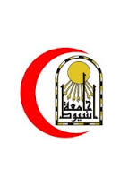 | Mohamed Ahmed Abdalhay Mohamed Alhussaini | 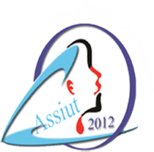

Contact Information Mohamed Ahmed Abdalhay Mohamed Alhussaini 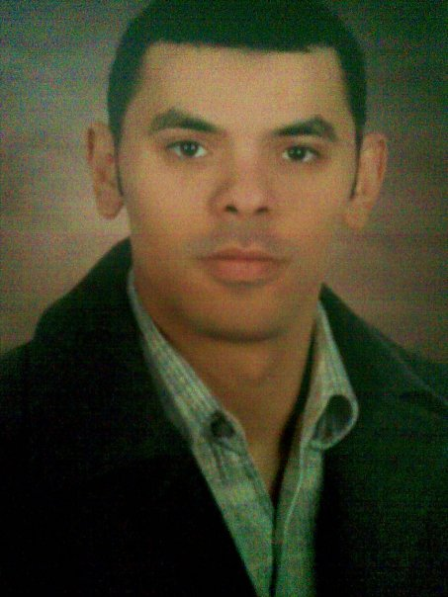
Assistant lecturer of Otorhinolaryngology,
Assiut University Hospital,
Assiut, Egypt
Tel: Home (+2088) 2320552, Office (+2088) 2413560, (+2088) 2413538
Fax: (+2088)(2333327)
Cell: (+2012) 24097935,(+2010)62537394,(+1)7204929534
E-Mail: alhussaini_mohamed@yahoo.com, Mohamed.Abd_elhay@med.au.edu.eg, Mohamed.Alhussaini@ucdenver.edu
Website: http://www.aun.edu.eg/membercv.php?M_ID=5204

Education:
- M.Sc. in Otorhinolaryngology: Faculty of Medicine, Assiut University, Excellent | June, 2012
- MB.Bch: Faculty of Medicine, Assiut University Excellence with Honor. Ranked 20th (class size 683 medical students) | September, 2007

Current positions:

- Visiting scholar at Anchutz medical campus,university of Colorado Denver,USA. October 2014-Present
- Otorhinolaryngology Assistant lecturer & Clinical Fellow: July,2012-Present
Assiut University Hospital, Assiut, Egypt. A tenure track position with both academic and clinical responsibilities, Enrolled in Endoscpic sinus surgery Research
- Doctorate Candidate: Department of Otorhinolaryngology, Faculty of Medicine, Assiut University. I have passed the First part of Doctor Degree in Otorhinolaryngology. | October, 2012 - Present
Positions held:
- Demonstrator (Otorhinolaryngology) Faculty of Medicine, Assiut University | March 2012 - July, 2012
- Resident (Otorhinolaryngology): Assiut University Hospital | March 2009- Feb 2012
- Intern (Mixed internship): Assiut University Hospital | March 2008- Feb 2009
Professional Licensure:
Licensed Physician 2009- Present
Egyptian Ministry of Health and Syndicate of Egyptian Physicians, no. 200155 (4/3/2009).
Egyptian Medical syndicate register,no.197155 (4/3/2009).
Egyptian Medical syndicate Ear Nose and Throat specialist register,no.3947 (24/7/2013).

Clinical Training:

Assiut University Hospital (http://www.aun.edu.eg/fac_med/medicin/Hospital2.htm) is one of the biggest University Hospitals in Egypt. It is the core referral center for the whole Upper Egypt that serves about twenty million people. The hospital contains 2027 beds, including 94 ICU beds, and 46 operative theaters in which 240 operations are performed daily. 1478 medical and 6428 paramedical staff serving in this hospital. 3000 patients visit the outpatient clinics and 1000 are received in the emergency departments daily. The department of Otorhinolaryngology contains 40 beds.
Through my training in this institution, I gained wide-ranging clinical experience including:

Skilled at:
Clinics and in-patient management:
- General Otorhinolaryngology outpatient clinic and inpatient care.
- Consultant for Otology and temporal bone surgery.
Otorhinolaryngologic emergencies:
- Urgent tracheostomy
- Dealing with nasal fractures and other effects of nasal trauma.
- Removal of foreign bodies in the nose, ear, pharynx and esophagus.
- Management of bleeding after adeno-tonsillectomy.
- Management of severe epistaxis.
Surgical procedures:
- Cortical mastoidectomy
- Radical and modified radical mastoidectomy
- Tympanoplasties
- Basic endoscipic sinus surgery.
- Functional endoscopic sinus surgery
- Reduction of the size of inferior nasal turbinate (by different methods)
- Endoscopic septal correction
- Rigid hypopharygoscopy and oesophagoscopy
- Myringotomy (with or without ventilation tube application)
- Adeno-tonsillectomy
- U3Ps
Moderately skilled at:
Surgical procedures:
- Stapes surgery
- Ossiculoplasty
- Facial nerve exploration
- Advanced endoscopic sinus surgery

Certification and Accreditation:

Conferences & Workshops attended  - THE FIRST ANNUAL COURSE FOR MICROSCOPIC ANDENDOSCOPIC APPROACHES TO THESKULL BASE ,Aurora, Colorado USA  - Colorado Mid winter meeting Vail Colorado USA  - Oto Alex 5th Annual conference, Alexandria, Egypt | March205  February 2015  September 2014
- Endoscopic sinus& skull base surgery course, Banha University; by Dr. Narayyan Janakirram (from India). | February 2013
- The 5th Assiut International Conference of Otolaryngology, Assiut, Egypt. | December 2012
- Oto Alex 2012 3rd Annual conference, Alexandria, Egypt.. | September 2012
- The Intermediate Training Program, Cairo, Egypt. | May 2011
- The 4th Assiut International Conference of Otolaryngology, Luxor, Egypt. | December 2010
Training and Fellowships:

- Endoscopic sinus surgery training fellowship at MCV memorial hospital, Pollachi , Coimbatore district, Tamil Nadu, India March & April 2014
- Observership and research fellowship at Anschutz medical campus, university of Colorado Denver ,USA. From October 2014 to present

Additional Experience:
The training program “Organization of Medical Conferences” held by the FLDP, Assiut University, Egypt. | May 19-21, 2012
The training program “Effective Data show” held by the FLDP, Assiut University, Egypt | May 22-24, 2012
The training program “Scientific Publication ” held by the FLDP, Assiut University, Egypt | May 26-28, 2012
The training program “Researh methodology” held by the FLDP, Assiut University, Egypt | May 28-30, 2012
The training program “Time and Meeting managment” held by the FLDP, Assiut University, Egypt  ICDL certificate | June 16-18, 2012  April 2008

Teaching activities:
- Involved in undergraduate student teaching March 2012 - Present
- Supervising the work of residents March,2012 - Present
- Supervising house officers March,2009 - Present

Research activities:
- Seven-block pyramid model to build up an endoscopic sinus surgeon, Ahmed H Monib M.Sc ¹, Mahamed M Alhussainia², Ahmed A Saleh¹ EJO, Year : 2015 | Volume : 31 | Issue : 1 | Page : 76-77
- - M.Sc. Thesis "complication of endoscopic sinus surgery", :Alhussaini M.A., Abd Al Aleem., Osman M.M.  General Interests and Skills:  - Photo-documentation of medical images& edition of medical videos.  - Computer work and Information Technology  - Involved in the Quality insurance program for training of Postgraduate candidates at Assiut university hospital. | 2011

Languages:
Arabic (native language), English (fluently), French (Novice Speaker), TOEFL®IBT (Internet-Based Test) exam on 9- 12- 2012 (total score 95).
References:
1-Name: Mohamed Abd Alaziz Mohamed Hassan
Title: Professor Emeritus
Affiliation: Faculty of Medicine Assiut University
Phone: 01023101045
Email: mohamed.hassan25@au.edu.eg, M.abdelaziz.elderwy@gmail.com

2-Name: Ahmed Abdelaleem Abdel wahab
Title: Head of ENT departmen
Affiliation: Faculty of Medicine Assiut University
Phone: 01005267182, 01222892745
Email: ahmed.abdelwahab1@med.au.edu.eg ahmedaleem56@yahoo.com

3-Name: Mohamed Mostafa Osman
Title: Lecturer
Affiliation: Faculty of Medicine Assiut University
Phone: 01005267182
Email: mohamedosman@aun.edu.eg Mohamedosman@yahoo.com

Thank you for the precious time spent reviewing this resume.

